
SHIRE HIGHLANDS EDUCATION DIVISION
2026 MALAWI SCHOOL CERTIFICATE OF EDUCATION MOCK
EXAMINATION

CLOTHING AND TEXTILES
Subject Number: M034/I
Monday, 9th March Time Allowed: 2 h 30 min
1:30- 4:00pm
PAPER I
(100 marks)
Theory
Instructions
Question  Number | Tick if  answered | Do not write in  These column
1
2
3
4
5
6
7
8
9
TOTAL
- This paper contains 8 printed pages. Please check.
- Write your Candidate Name at the top of each page of the question paper.
- You are required to answer all the questions in Section A and two questions from Section B.
- The maximum number of marks for each answer is indicated against each question.
- In the table provided in this page, tick against the number of the questions you have answered.
- Hand in your question paper to the invigilator when the time is called to stop writing.

SECTION A (60 marks)
Answer all questions in this section in the spaces provided
- a. Give any two advantages of a flatbed knitting machines?
______________________________________________________________________________________________________________________________________ (2 marks)
b. Mention any two characteristic of a portable lock machine.
________________________________________________________________ (2 mark)
Figure 1 shows a fabric finishing technique. Use it to answer the questions that follows.
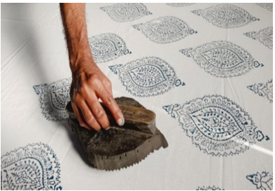
- a. Identify the type of fabric finishing technique.
________________________________________________________________ (1 mark)
b. Mention the two advantages for the fabric finishing technique.
_______________________________________________________________ (1 mark)
_______________________________________________________________ (1 mark)
c. Describe any two similarities between gathers and pleats in garment construction.
_______________________________________________________________________________________________________________________________________________________________________________________________________________________________________________________________________________________ (4 marks)
- a. Explain any one way in which form differs from shape in textile design.
_______________________________________________________________________________________________________________________________________ (2 marks)

b. What is the effect of the following lines when designing the interior decoration.
i. vertical lines
____________________________________________________________________________________________________________________________ (2 marks)
ii. curved lines
_________________________________________________________________________________________________________________________ (2 marks)
iii. horizontal lines
_________________________________________________________________________________________________________________________ (2 marks)
- a. Describe the following components of a guide sheet used during garment construction
- fabric specification
___________________________________________________________________________________________________________________________ (2 marks)
(ii) technical diagrams
___________________________________________________________________________________________________________________________ (2 marks)
b. Explain the two main reasons that necessitate pattern alteration in fashion design?
_______________________________________________________________________________________________________________________________________________________________________________________________________________________________________________________________________________________(2 marks)
c. Give any three reasons for oiling the knitting machine frequently.
_______________________________________________________________________________________________________________________________________________________________________________________________________________ (3 marks)

Figure 2 shows principles of design in textiles. Use it to answer the questions that follows.

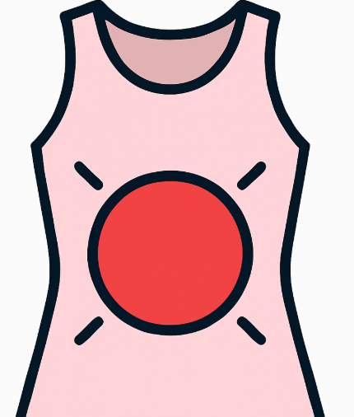
J K
- a. Mention the principles of design used during garment construction.
J __________________________________________________________ (1 mark)
K __________________________________________________________ (1 mark)

b. How are the principles of design applied in relation to body grooming?
J: ___________________________________________________________________
___________________________________________________________ (1 mark)
K: ___________________________________________________________________
___________________________________________________________(1 mark)

c. Explain three ways of controlling negative effects of fabrication processes on the environment.
- _________________________________________________________________________________________________________________________ (2 marks)
- _________________________________________________________________________________________________________________________ (2 marks)
- _________________________________________________________________________________________________________________________ (2 marks)
- a. Explain any three guidelines to follow when constructing children’s garments.
_______________________________________________________________________________________________________________________________________________________________________________________________________________________________________________________________________________________________________________________________________________________________________________________________________________________________________ (6 marks)
b. Explain any two ways in which brands of textile products influence consumer behaviour.
______________________________________________________________________________________________________________________________________________________________________________________________________________________________________________________________________________________ (4 marks)
c. How does each of the following factors affect a Clothing manufacturing Industry.
i. marketing opportunities
___________________________________________________________________________________________________________________________ (2 marks)
ii. access to finances
___________________________________________________________________________________________________________________________ (2 marks)
d. Explain any two disadvantages of partnership business in Clothing and Textile Industry. _______________________________________________________________________________________________________________________________________________________________________________________________________________________________________________________________________________________ (4 marks)
SECTION B (40 minutes)
Answer any two questions from this section in the spaces provided.
- a. Describe the process of laundering a polyester chair back.
_______________________________________________________________________________________________________________________________________________________________________________________________________________________________________________________________________________________________________________________________________________________________________________________________________________________________________________________________________________________________________________________________________________________________________________________________________________________________________________________________ (8 marks)
b. With an aid of a well labeled diagram, explain the five stages of a fashion cycle.
______________________________________________________________________________________________________________________________________________________________________________________________________________________________________________________________________________________________________________________________________________________________________________________________________________________________________________________________________________________________________________________________________________________________________________________________________________________________________________________________________________________________________________________________________________________________________________________________________________________________________________________________________________________________________________________________________________________________________________________________________________________________________________________________________________________________________________________________________________________________________________________________________________________________________________________________________________________________________________________________________________________________________________________________________________ (12 marks)
- a. Explain any five ways in which stain removal is important in laundry processes.
______________________________________________________________________________________________________________________________________________________________________________________________________________________________________________________________________________________________________________________________________________________________________________________________________________________________________________________________________________________________________________________________________________________________________________________________________________________________________________________________________________________________________________________________________________________________________________________________________________________________________________________________________________________________________________________________________________________________________________________________________________________________________________________________________________________________________________ (10 marks)
b. Describe the steps followed when laying-out a pattern in garment construction.
_____________________________________________________________________________________________________________________________________________________________________________________________________________________________________________________________________________________________________________________________________________________________________________________________________________________________________________________________________________________________________________________________________________________________________________________________________________________________________________________________________________________________________________________________________________________________________________________________________________________________________________________________________________________________________________________________________________________________________________________________________________________________________________________________________________________________________________________________________________________________________________________________________________________________________________________________ (10 marks)
- a. Explain the five ways of repairing torn parts in garments.
______________________________________________________________________________________________________________________________________________________________________________________________________________________________________________________________________________________________________________________________________________________________________________________________________________________________________________________________________________________________________________________________________________________________________________________________________________________________________________________________________________________________________________________________________________________________________________________________________________________________________________________________________________________________________________________________________________________________________________________________________________________________________________________________________________________________________________________________________________________________________________________________________________________________________________________________________________________________________________________________________ (10 marks)
b. Explain the five activities a textile entrepreneur is engaged in when identifying resources for developing a small-scale business.
______________________________________________________________________________________________________________________________________________________________________________________________________________________________________________________________________________________________________________________________________________________________________________________________________________________________________________________________________________________________________________________________________________________________________________________________________________________________________________________________________________________________________________________________________________________________________________________________________________________________________________________________________________________________________________________________________________________________________________________________________________________________________________________________________________________________________________________________________________________________________________________________________________________________________________________________________________________________________________________________________________________________________________________________________________________________________________________________________________________ (10 marks)
END OF QUESTION PAPER
This question paper contains 8 pages

